Specify official title of the course

- Category | - Go to „Offered in“ on the VVZ website
- Session | - XS 20XX | - Duration | - X Hours XX Minutes
- Lecturer | - First Name Surname 1, other lecturers
- Author | - First Name Surname 1, other authors

Description of the examination procedure
Here you can describe what the atmosphere was like during the exam. For example, what aids were allowed, how long the reading time was, how you experienced the time pressure, where the exam took place and how the space was, etc. In fact, everything that could help future students imagine the exam situation as precisely as possible. You should add the most important points as bullet points so that they are clear for everyone. You can add further details as text. Example:
- Permitted aids: 10-page (5 A4 sheets) digital or handwritten summary, simple calculator.
- Reading-in/preparation time: 10 minutes, after which questions were clarified
Further information: Great time pressure, otherwise pleasant atmosphere in the examination room with enough space on the tables for the aids.

Task list 1

Task 1: Template for Text or Arithmetic Exercises.
Give as precise a task description as possible, along with point distribution and intermediate results. If the task consists of several sub-questions, they should be listed below. If a diagram or a relevant figure/drawing was given, please add it as a picture (draw it yourself or use a picture from the examination) at the end of the task description or relevant sub-question.

Sub-question 1

Sup-question 2

Task 2: Template for Multiple/Single Choice/Correct-False Exercises.
Always note if wrong answer gives negative points. Create a separate table with the possible answers for each question. This is so that "cuts" can be inserted more clearly and easily on Community Solutions.
Template Multiple/Single Choice Exercises
Question
Statement 1
Statement 2
Statement 3
Statement 4

Template Correct-False Exercises
Frage | Correct | False
Statement 1
Statement 2
Statement 3
Statement 4

Task 3: Template TextBox Exercises
TextBox exercises are tasks where only the result has to be given and the calculation method is not relevant. The template is a mixture of the previous two examples. Under Question comes the detailed description of the task and under Result come the values/results that have to be determined.
Task description | Result
Excercise 1 | Gesuchte Werte

On the next page you will find examples of the exercises listed above.

Task 1: Example for Text or Arithmetic Exercises [9.5 Points]
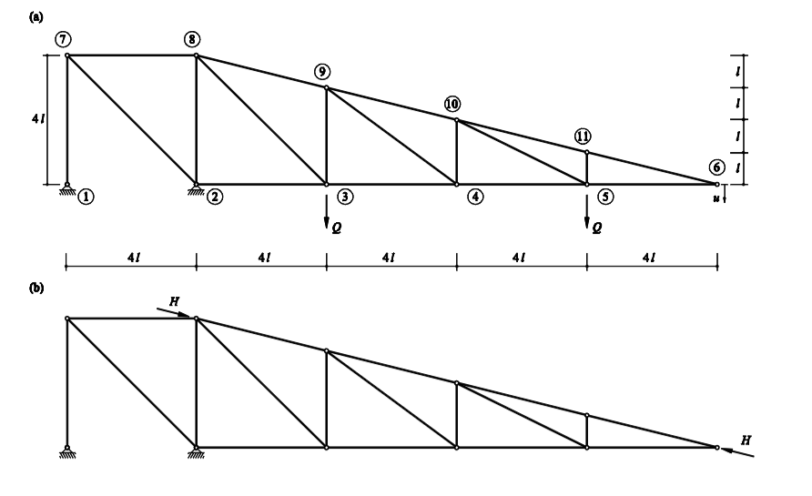
The beam shown in the picture is designed as an ideal truss. Nodes 3 and 5 are each subjected to a concentrated load of magnitude Q. Use the templates on the solution sheet to solve the problems. The following tasks are to be solved:

Determine the bar forces of the system in figure (a). You can state the bar forces in terms of their vertical and horizontal components.

Determine the vertical displacement u at point 6 of the system in Fig. (a)
The resulting vertical displacement is too large. Therefore, two different measures should be investigated to reduce the vertical displacement in point 6 by ∆u. Use $Δu=\frac{1}{10l}$
- The member 1-7 is to be installed shortened. By how much must you shorten member 1-7 so that the total vertical displacement is reduced by ∆u?

Task 2a: Example Multiple Choice exercises

Tick all the correct statements [6 Points]
Oedometer and consolidation
Both the effective and the total vertical stresses in the lower gravel sand layer are increased by the lowering of the groundwater level.
When the groundwater level is lowered, the effective vertical stresses in the lower gravel sand layer remain unchanged.
The lowering of the groundwater level causes a decrease in the effective vertical stresses in the lower gravel sand layer.
Building plot
The specific surface area of clayey soils is much larger than the specific surface area of coarse-grained soils.
In layered soils, the vertical permeability is often much greater than the horizontal permeability.
Sea chalk is a coarse-grained soil that has a very low stability and load-bearing capacity and is therefore geotechnically very problematic.

Task 2b: Example Correct-False exercise
Tick whether the statements below are true or false. As many partial points are awarded per question as there are questions (example: question on 1 point with 4 partial questions → there are a total of 4 partial points for the question). A correctly set cross results in 1 partial point, a wrongly set cross leads to the deduction of 1 partial point. If no cross is set, neither a partial point nor a deduction is awarded. At least 0 points are scored per question.

Theory questions – Correct/False
A S460J2 steel is to be used for a construction project. Which statements are correct? | Correct | False
The yield strength of the material is at least 460 N/mm² for small sheet thicknesses.
The notched impact strength (in joules) of the material must exceed 27J at -20°C.
There are special requirements with regard to the constriction of the fracture in the direction of the thickness.
The fracture toughness of the material is clearly defined by these specifications.

Which of these statements about steel and composite construction components are true? | Correct | False
Steel structures are among the lightweight construction methods.
A Vierendeel girder can be designed with slimmer bars than a truss.
Trusses can be manufactured with smaller dimensions (height, width) than solid wall girders of the same load-bearing capacity.
Stiffeners (longitudinal and transverse) prevent stress concentrations from forming and thus locally increase fatigue strength.

Task 3: Example TextBox exercise
In this exercise, only the final result is important, not the calculation method. Write your result in the box provided. Each wrong answer or no answer is worth 0 points. [10 points]
Only the result in the box counts!

[2 points]
Question | Result
Determine $a,b∈R$ so that the function $f$ : $R→R$ given as  $$f\left(x\right)=\left\{\begin{aligned}a\cos\left(πx\right) für x<1 \\ 2x-ln\left(x\right) für 1≤x≤e \\ x+b für x≥e \end{aligned}\right.$$  Is continuous everywhere. | $$a=$$  $$b=$$

[2 points]
Question | Result
Determine the directional derivative of the function  $$f\left(x,y\right)=\sqrt{x^{2}+{7y}^{2}}$$  on point (3, 1) in the direction $v={(-1, 1)}^{T}$ | $$D_{v}f\left(3, 1\right)=$$

